Name:
- Species- Grey wolf, Canis lupus
- A character table and Phylogenetic tree (5 species and 4 characters)
Species/character | Belong to family Canidae | Live in the United States of America | Wolves have White fur | Males bigger than females
Gray wolf (Canis lupus) | 1 | 1 | 1 | 1
Arctic Wolf (Canis lupus arctos) | 1 | 1 | 1 | 1
Red Wolf (Canis lupus rufus) | 1 | 1 | 0 | 1
Indian Wolf (Canis lupus pallipes) | 1 | 0 | 1 | 1
Ethiopian Wolf (Canis simensis) | 1 | 0 | 1 | 1

Ethiopian wolf
Canidae Indian wolf
Live in US Red wolf
Having fur Arctic wolf
Male bigger than female Gray wolf

- Habitat and Community
- As an indication of gray wolves range, the gray wolves are able to live in so many biomes with the inclusion of dense forests, Arctic tundra, and even dry shrublands. “In addition, as long as there is food in plenty, the gray wolves can live in many biomes.” (Lilley, 2017)
- One abiotic factor of gray wolves is mean temperature. Gray wolves adapt well to snow and cold, for instance, as they have large paws, and during the winter, they act as snowshoes.
- One gray wolves’ biotic factor is the population of other predators like black bears as well as other predators that are large and can reduce gray wolves’ population. Gray wolves adapt to predators' population as they deploy flexible methods of hunting thus making their predatory a success and therefore, they get food regularly.

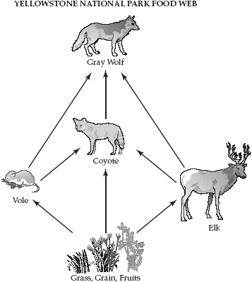
Image credit: Yellow Stone National Park

4.

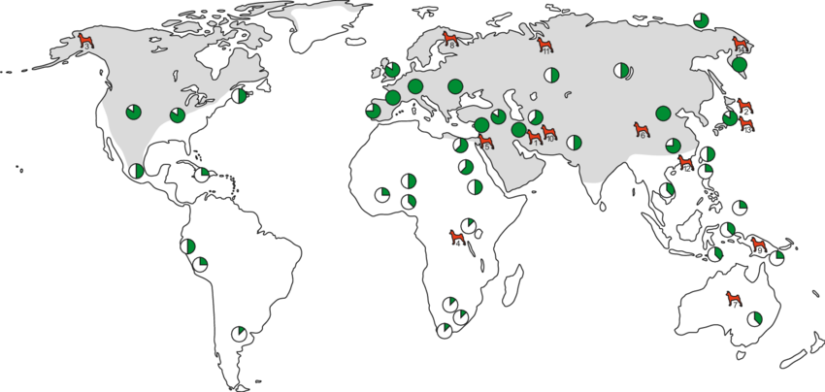
Grey- Range of gray wolves
Green- Where Gray wolves remain
Red- Basal breed dog

- Gray wolves status of the population is relatively stable despite facing some threats. This implies that since the trend of the gray wolves does not meet or meet nearly any criteria of classifying them as a threatened species, the gray wolves population is relatively stable and relatively widespread range.

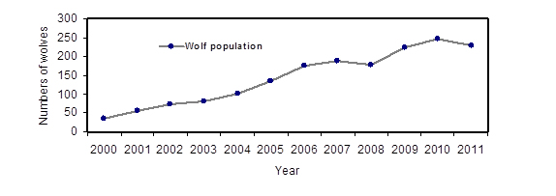
The above graph shows the population growth of gray wolves from Wyoming Gray Wolf Recovery Status Report.
- From the population growth in the above graph, gray wolves do not migrate but travel in areas that are large in order to hunt. However, gray wolves disperse whenever seeking mates and may travel many miles.
- The population structure of gray wolves is social groups which are family-based and in order to avoid inbreeding and competition from kin, they primarily depend on dispersal.
- The maturity rate in gray wolves is faster in female pups as they take two years of age to reach maturity while males take 3 years of age so as to reach maturity. Overall, gray wolves mature quickly. On the other hand a female gray wolf produces litters of about 4-7 pups. (Wydeven, Van & Heske, 2009)

- Gray wolves live and thrive in habitats that are diversified and they range from forests, deserts, grasslands, woodlands and tundra. These habitats are not intact as they face the threat of deliberate persecution due to livestock depreciation.
- One of the gray wolf's survival threat is the human-wildlife conflict.
- “One way that can be used in mitigating the human-wildlife conflict is guiding the movement of gray wolves in developed areas by fencing their habitats with electric fence.” (Mladenoff et al, 1995)

- References
Lilley, D. (2017). The wolf: Canis lupus - lac lupinum - the grey wolf : a mythological and comparative study.Mech, L. D., & Boitani, L. (2006). Wolves: Behavior, ecology, and conservation.
Mladenoff, D. J., Sickley, T. A., Haight, R. G., & Wydeven, A. P. (1995). A regional landscape analysis and prediction of favorable gray wolf habitat in the northern Great Lakes region. Conservation Biology, 9(2), 279-294.
Wayne, R. K., Lehman, N., Girman, D., Gogan, P. J. P., Gilbert, D. A., Hansen, K., ... & Krumenaker, R. J. (1991). Conservation genetics of the endangered Isle Royale gray wolf. Conservation Biology, 5(1), 41-51.

Wydeven, A. P., Van, D. T. R., & Heske, E. J. (2009). Recovery of gray wolves in the Great Lakes Region of the United States: An endangered species success story. New York: Springer-Verlag.

Yellowstone National Park website accessed on 14/05/2020 at 8:00 AM https://www.nps.gov/yell/learn/nature/wolf-restoration.htm

